Battle of Neighborhoods

1. Introduction Section :

[Discussion of the business problem and the audience who would be interested in this project.]

Scenario:
I am data scientist in Finland. I currently live within short distance to Tampere. I have offer to work with data scientic problem and I want to use this opportunity to practice my learnings in Coursera in My customer needs to know how can find a convenient and enjoyable place to buy good investment in apartment. I can use available real estate apps and Google but the idea is to use and apply myself the learned tools during the course. In order to make a comparison and evaluation of the rental options in Tampere, I must set some basis, therefore the apartment in Tampere must meet the following demands:
- apartment must be quite small, 1 bedrooms
- desired location is near a local tranportation in the Tampere area and within 1.0 km radius
- How apartments selling prices are progressed after year 2010.
- How neighborhood areas are located in the Tampere.

Business Problem:
The challenge is to find a suitable apartment to buy as investment for renting in Tampere that complies with the demands on location and price. The data required to resolve this challenge is described in the following sections

Interested Audience:
I believe this is a relevant challenge with valid questions for anyone moving to other large city or want to invest their wealth. The same methodology can be applied in accordance to demands as applicable. This case is also applicable for anyone interested in exploring starting or locating a new business in any city. Lastly, it can also serve as a good practical exercise to develop Data Science skills.

2. Data Section:

Description of the data and its sources that will be used to solve the problem-

Description of the Data:
The following data is required to answer the issues of the problem:
- List of neighborhoods of Tampere with their geodata (latitud and longitud)
- List of apartments to sold in Tampere area with their addresses and price
- List of apartment for sale with additional information, such as price, address, area, # of beds, etc
- Venues for each Tampere neighborhoods

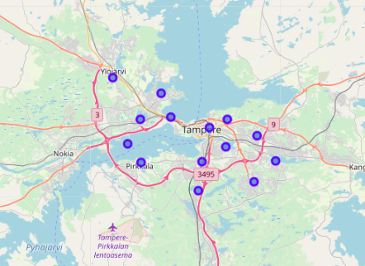

Location of each neighborhoods

How the data will be used to solve the problem:
The data will be used as follows:
- Foursquare and geopy data to map (top 10 venues) for all Tampere neighborhoods.
- foursquare and geopy data to map the location of bus stops.
- Foursquare and geopy data to map the location of rental places.
- Data will be searched in open data sources if available, from real estate sites if open to reading, libraries or other government agencies such as Tilastokeskus, etc.
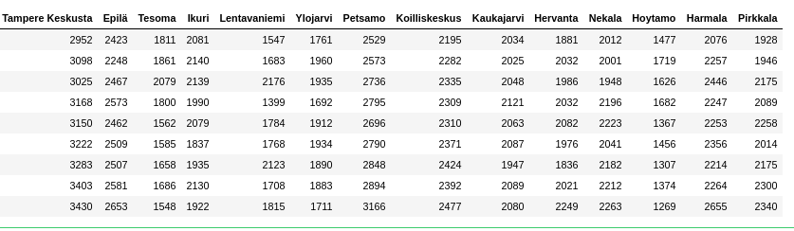
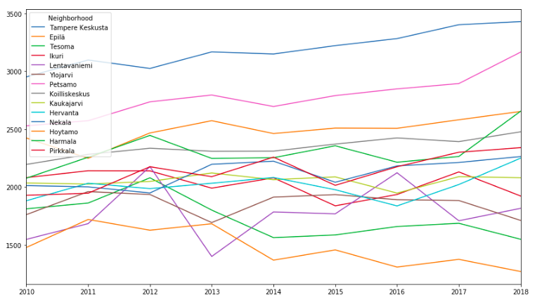
Dataframe of how prices are developed each neighborhoods
Price developing in plotted lines
The procesing of these DATA will allow to answer the key questions to make a decision:
- what is selling price (per square meter) around a neighbourhood.
- what is the area of Tampere with best value of investment that meets criteria established?
- What is the distance available from work places and the tentative future home?
- What are the venues of the two best places to live? How the prices compare?
- How venues distribute among Tampere neighborhoods and around train stations?
- Any other interesting statistical data findings of the real estate and overall data.
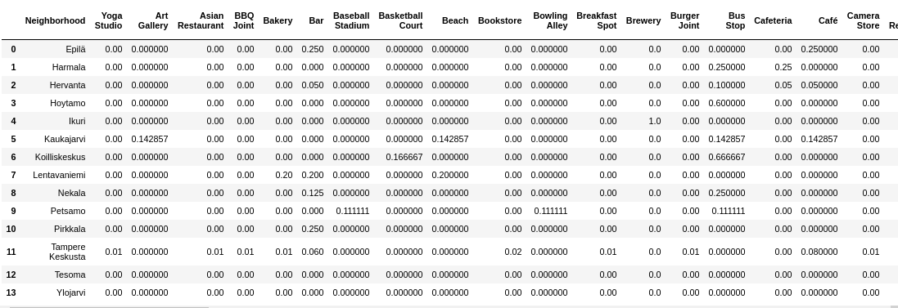
We can see where is lot of venues and workplaces. That is reason for high prices and good oppornity to investing that area.

